

***Department of Computer Science & Engineering***

**Course Title –** Peripherals and Interfacing Lab

**Course Code –** CSE 316

**Section** - A1

Final Project

***Ultrasonic Shooter***

**Date of Submission –** April 9, 2022

**Submitted by:**

Md. Hasibur Rahman (19101009)

Tanmoy Mazumder (19101013)

Shawan Das (19101020)

**Submitted to:**

Abdullah Al Omar

Lecturer,

CSE, University of Asia Pacific

**Abstract**

The ultrasonic module is widely used to measure distance and detect objects. The speed of sound makes the detection almost instantaneous, especially for the range of the sonar module(~1 Meter). Using this principle, The sensor can be used as a gun’s ammunition and at the same time used to detect if a target has properly been hit. Using an Arduino board, moving targets can be arranged to build a mini shooting range with a score system.

**Motivation**

Shooting video games are growing popular each day. However, holding an actual shooting device is a whole different experience altogether, and significantly more fun for target practice.

This experience can be obtained through one of two ways: Shooting at an actual gun range with real weapons, which is immensely dangerous and often not worth the risk, cost, and additional effort. The other is doing so with non-lethal ammunition such as paint-ball, laser tag, and similar arrangements. However, these are quite expensive and require a lot of resources.

Considering these facts, we propose an inexpensive mini target practice system that utilizes the ultrasonic sensor to both shoot and confirm target hit.

**Existing Similar Projects**

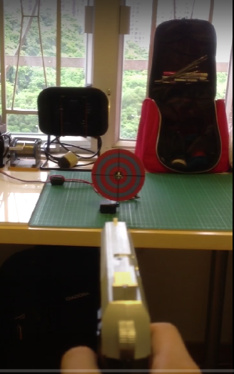[Laser Shooting game(Star Wars)](https://create.arduino.cc/projecthub/Barqunics/laser-shooting-game-star-wars-f4acd8) [Laser Shooting Game](https://www.instructables.com/Laser-Shooting-Game/) [Arduino Target Game](https://www.youtube.com/watch?v=AYLWPSkZQog) .

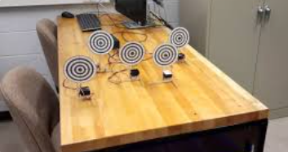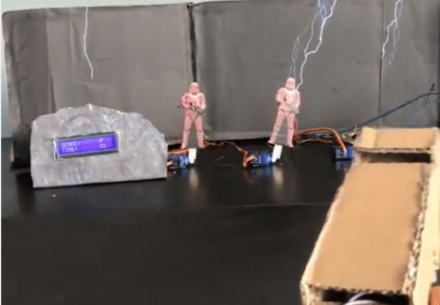

**How it’s different**

Each of the projects mentioned in the previous section use laser, along with laser detection module on each of the targets. The detection module costs a significant amount of money. Our project utilizes the ultrasonic sensor to detect if the target has been hit. This enables the project to be built in a far tighter budget.

Our project also makes it more realistic by adding a trigger to send the ultrasonic pulse, like shooting real ammunition, making it more realistic than the continuous stream of laser.

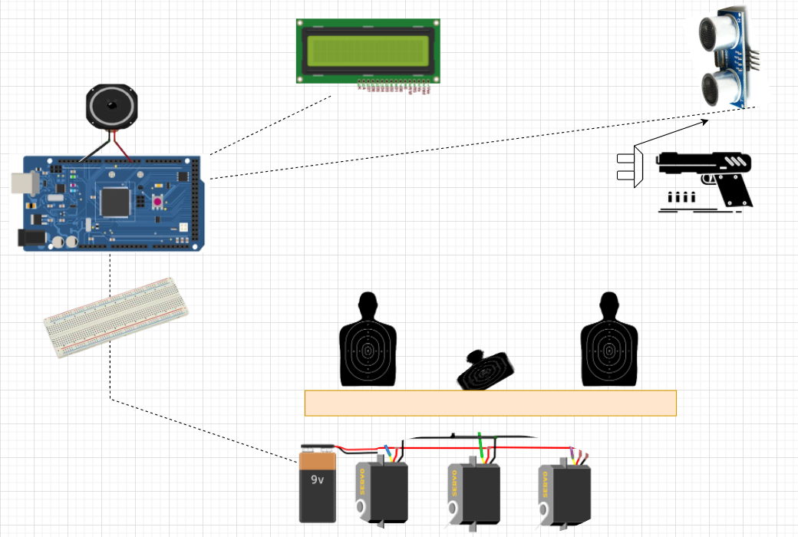 **Budget**

* Arduino mega - 1850/=
* Jumper wires x 50 - 200/=

# Sonar Sensor (HC-SR04) - 150/=

* Servo Motor MG995 x 3 – 3750/=
* Cardboard - 120/=
* Gun - 250/=
* Battery x 4 – 240/=
* Button - 50/=
* [LCD Module](https://techshopbd.com/detail?product_id=1342) - 220/=
* Breadboard - 150/=